**Use Case Diagram**

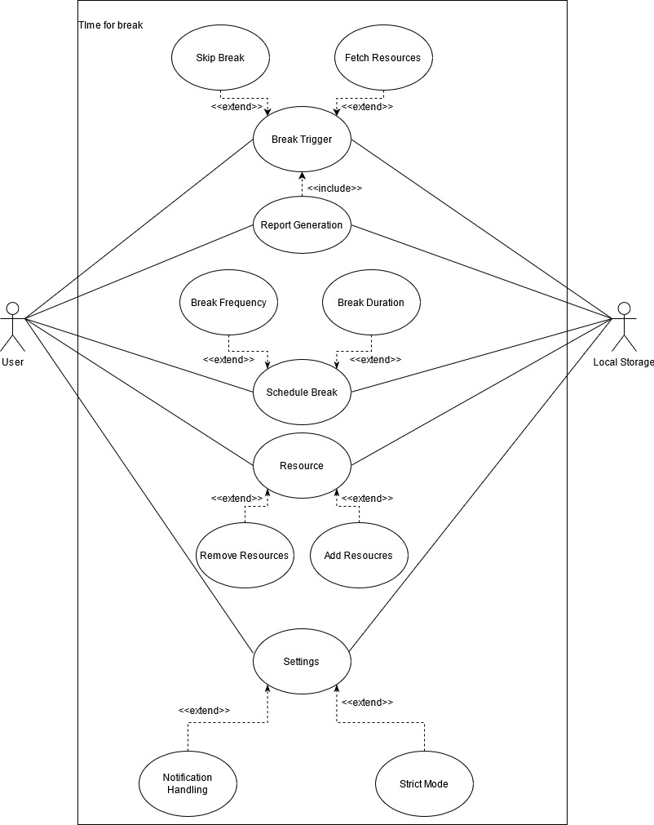

**Use Case Description**

|  |  |
| --- | --- |
| **Use Case Name** | **settings** |
| **Description** | By going through this use case(Activity), System users can change settings in the app for their system. It consists of Notification preference and Strict Mode. |
| **Precondition** | There is no restriction(Condition) unless the user can’t access the Settings Page. |
| **PostCondition** | If the user has not changed anything then the previous settings should be kept intact else the new ones should be applied and saved in the local storage. |
| **Basic Flow (System Happiness)** | The user starts the app during the time other than the break time(Trigger period specified by user) and opens the settings and then he/she may  i**)** adjust app notifications i.e whether notification should appear before 5 seconds of any break or not.  **ii)** set the strict mode in the app. By enabling strict mode, ‘skip the break’ button (through which the user can skip any particular long or short break) will not appear in the break window.  **iii)** keep the default settings as it is. |
| **Alternative Flow** | Notifications are enabled by default. |

|  |  |
| --- | --- |
| **Use Case Name** | **App/Break Trigger** |
| **Description** | App would trigger at the specified period with the specified action and would remain active for some certain time period given by the user. The App can also be terminated by the user before its terminating time. |
| **Precondition** | The time at which the app should trigger, the time period range during which the app should be active and the action to be carried out; these quantities should be specified by the user and also during the specified active time, system should be on. |
| **PostCondition** | After the completion of the break event, all information and user activity(User activeness, forced termination etc) during that time should be saved in the database and should be added in the report being generated after the end of that session. |
| **Basic Flow (System Happiness)** | At the certain exact time(given by the user), the app triggers and implements some certain actions(Audio, notifications etc, it would fetch these data from the local database) for some certain time period(given by the user). To render the idea(quotation) or to provide the music, this page will fetch one idea and music file randomly from the existing ideas and music files from the local storage.  Now in some cases, when some break is active and rendering some actions, the user can terminate it too using the ‘Skip the break’ button available on the break window if the strict mode is off. |
| **Alternative Flow** | => If the user hasn’t given the data for the actions to be implemented during some break time, then the app will render the default actions.  => If the system turns off while the break time is on then the break should terminate abruptly. |

|  |  |
| --- | --- |
| **Use Case Name** | **Report generation** |
| **Description** | Whenever the user goes into the report page, the page will render the report of the previous session. |
| **Precondition** | This use case includes the break trigger use case. So if no breaks have occurred in the system after the installation of the app, the report will show empty/zero values. |
| **PostCondition** | After the end of each session, all the required information should be stored in the local storage successfully so that it can be used while rendering the report page. |
| **Basic Flow (System Happiness)** | The user has ended the current running session. So then all the required information will be stored in the local storage immediately. Then at any point of time when user goes into the report page, it will show following informations about the previous session;   * Total duration of the session * Number of short breaks skipped * Number of short breaks attended * Number of long breaks skipped * Number of long breaks attended * Percentage of total breaks attended * On the basis of the percentage(75% is the threshold), greet message will be shown(Congratulation/Try hard) |
| **Alternative Flow** | At any time(even when the current session is running), the user goes into the report page, it will show the report of the previous session. |

|  |  |
| --- | --- |
| **Use Case Name** | **Schedule** |
| **Description** | By going through this use case(Activity), System users can change certain quantities related with breaks i.e duration and frequency for short and long breaks. |
| **Precondition** | There is no restriction(Condition) unless the user can’t access the Schedule Page. |
| **PostCondition** | If the user has not changed anything then the previous settings should be kept intact else the new ones should be applied and saved in the local storage. |
| **Basic Flow (System Happiness)** | The user starts the app during the time other than the break time(Trigger period specified by user) and opens the schedule and then he/she may  i**)** change two quantities(duration and frequency) for long and short breaks.  **ii)** Duration of a break stands for how long that break should last and frequency stands for after what time that break should trigger.  **iii)** keep the default schedule as it is. |
| **Alternative Flow** | At the very start, the default value for all four variables(short duration, short frequency, long duration, long frequency) is set as 1min. |

|  |  |
| --- | --- |
| **Use Case Name** | **Resources** |
| **Description** | Resources page consists of two major parts i.e ideas and music. They both have separate routes to go and the user can handle(change or keep) them independently. |
| **Precondition** | The user should be able to go through the routes of ideas and music. In music, the user can add only .mp3 and .wav music file formats. |
| **PostCondition** | If the user has not changed anything then the previous resources should be kept intact else the new ones should be applied and saved in the local storage and also should be rendered on their respective pages in real time. |
| **Basic Flow (System Happiness)** | The user starts the app during the time other than the break time(Trigger period specified by user) and opens the resources page and then he/she may  i**)** add some new ideas or remove the existing ones in the section of ideas in resources.  **ii)** add some new supported music files or remove the existing ones in the section of music in resources. Also the user can play the existing music music files here.  **iii)** keep the default resources as it is. |
| **Alternative Flow** | Some default 5-6 ideas and one default music file will be added and these default data can not be deleted by the user. |